**Multimedia & Graphics**

**Class Six**

**Lab 18**

|  |
| --- |
| Lab Objectives:Design a advertisement poster for smart phone |

# Scenario

Suppose you are the owner of a smart phone company. Recently you have launched a new phone. To attract the customer you have to design a poster so that people can easily understand about the look and features of your phone.

# ফেব্রুয়ারী 11 IMG_256Example

# Task

You have to design a poster like this.

Core attributes of this poster are:

1. A rectangular line frame over the poster
2. Picture of your smartphone
3. Heading (Name of your smartphone)
4. Features name and related logo

ex. If Android 8.1 is a feature name the related logo should be like below

IMG_256

We will collect all the images or related pictures from Google. The background less images are called png type image. png is the extension of background less image. We will use png image to design our poster.

# Step 1:

Create a canvas of 1280 px width : 720 px height.

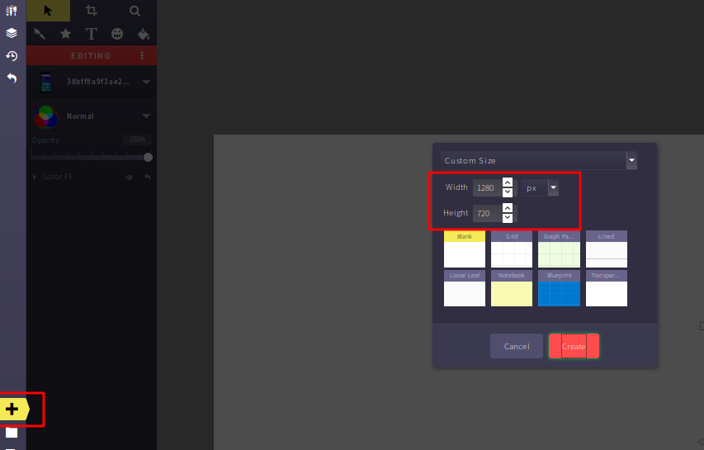

# Step 2:

Search smartphone png photo from Google.

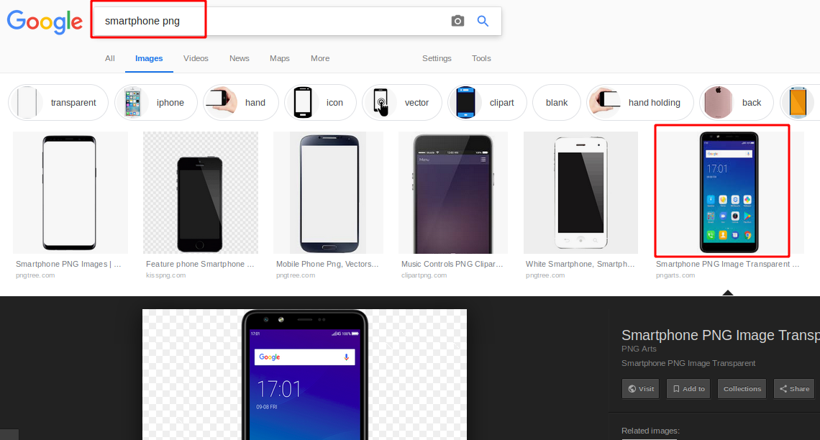

Right click on the image and copy the image

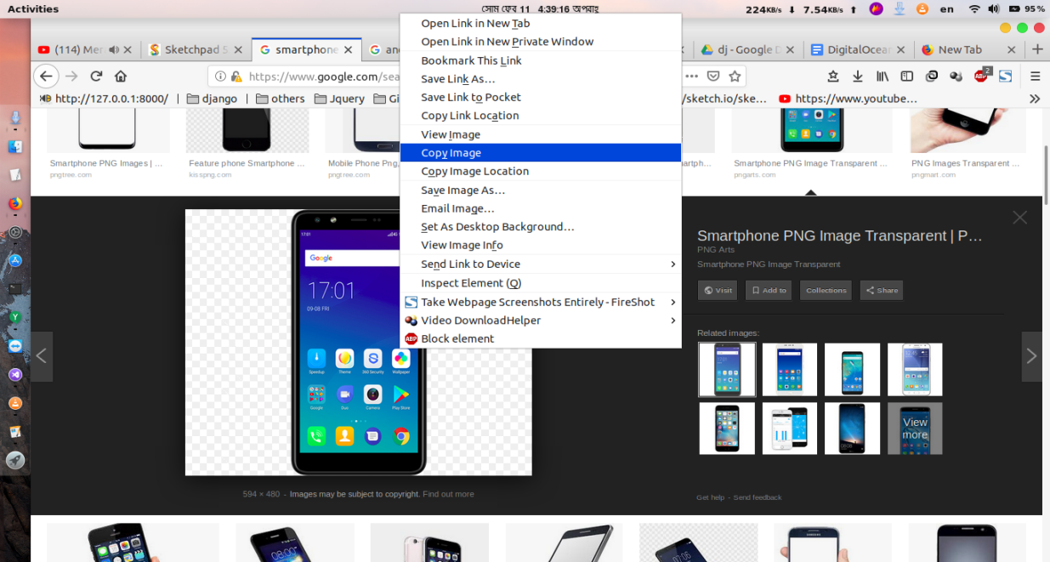

# Step 3:

Paste with ( Ctrl+V ) and move the smartphone to the left. Use select tool to move.

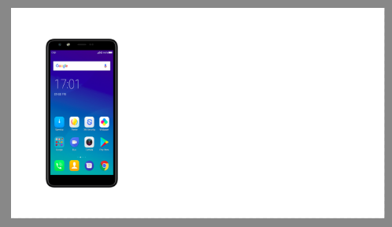

# Step 4:

Write the heading (smartphone name). Suppose the name of your phone is United Phone.

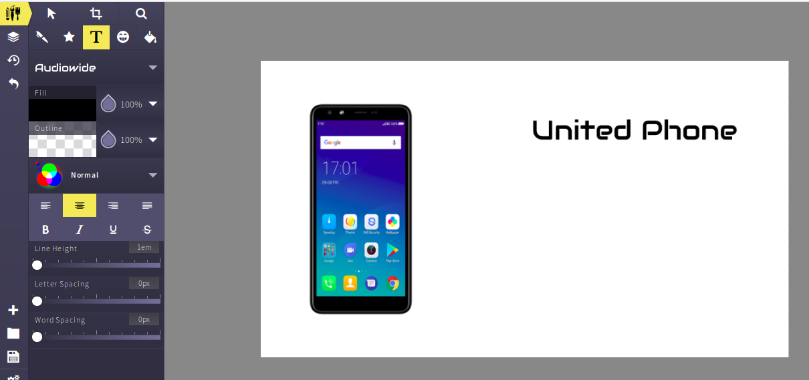

We have used “Audiowide” font to write United phone. You can use which one you like most.

Now you have to write the features of your phone.

Suppose your features are

1. Android 9
2. 25 MP rear + 10 MP front Camera
3. 400 mAh battery
4. 6 GB ram

Find the related picture from Google and add it to your poster.

# Step 5:

Search and add android png robot

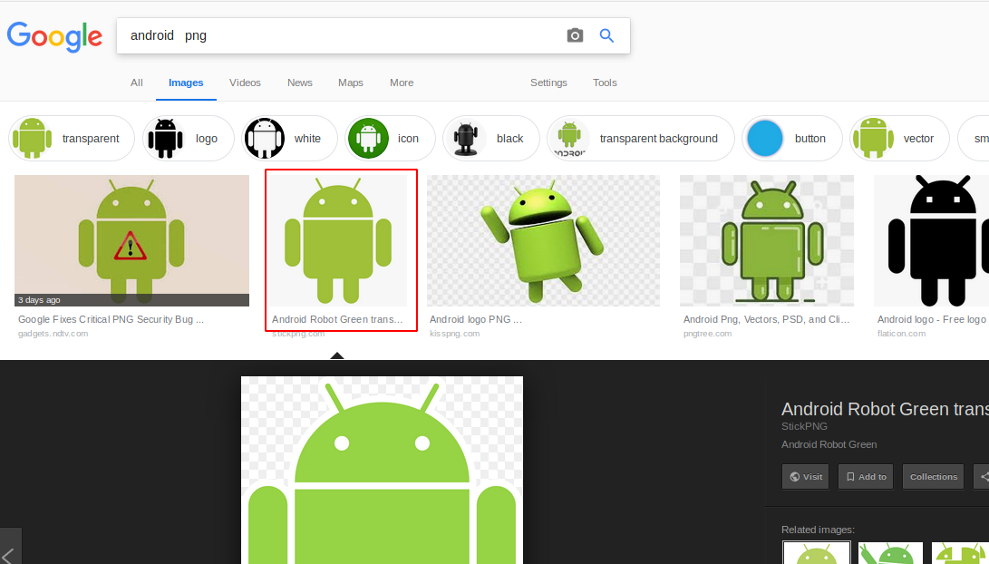

Ctrl + V to sketchpad canvas



Use select tool to move and resize your image

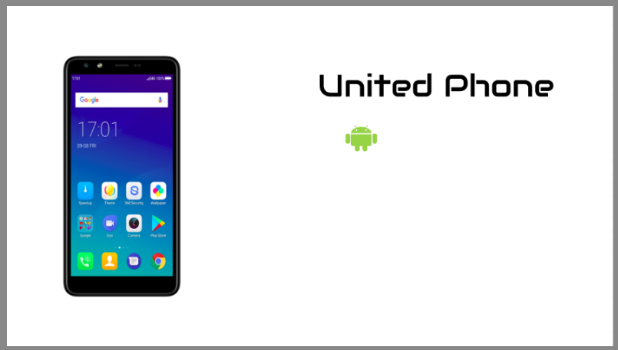

Add text beside the logo. Use any of your favorite font from text tool

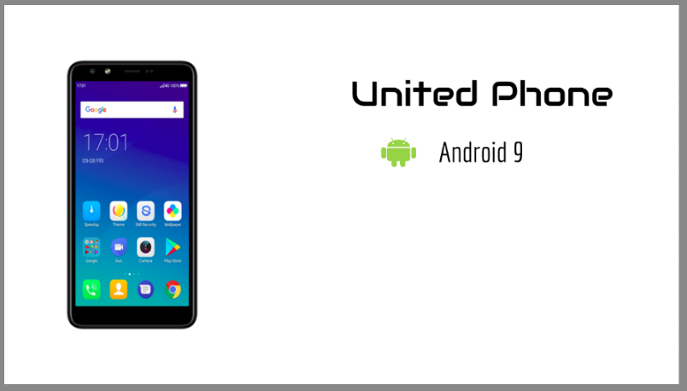

# Step 6:

Add camera features and related photo

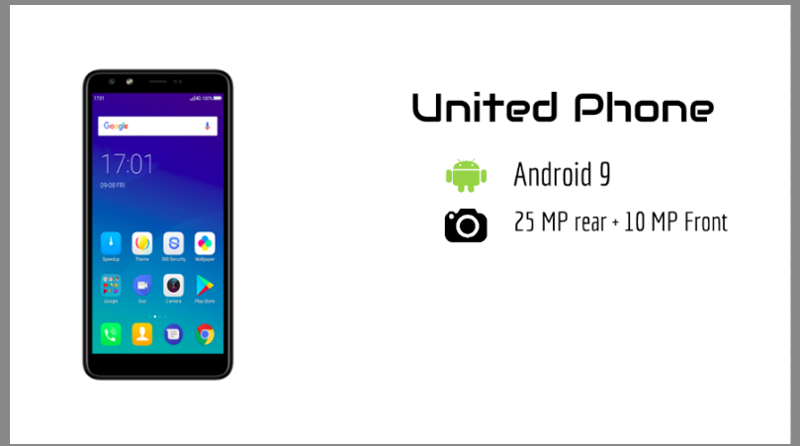

# Step 7

Add battery features and related photo

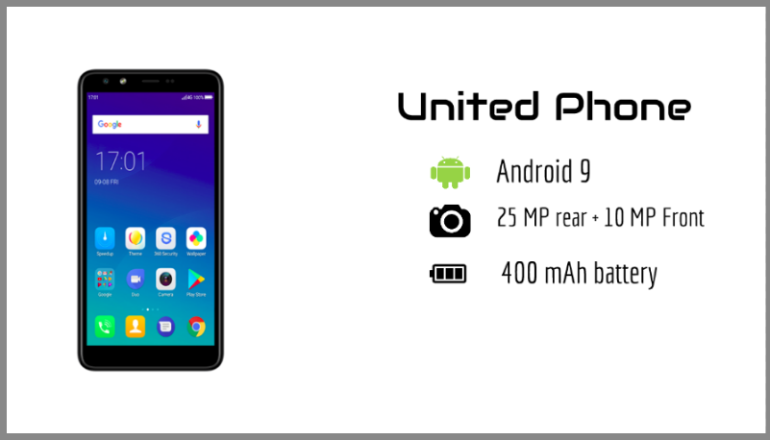

# Step 8:

Add ram features and related photo

# ফেব্রুয়ারী 11 _10

# Step 8:

Now add a rectangular frame over the poster. Use line brush

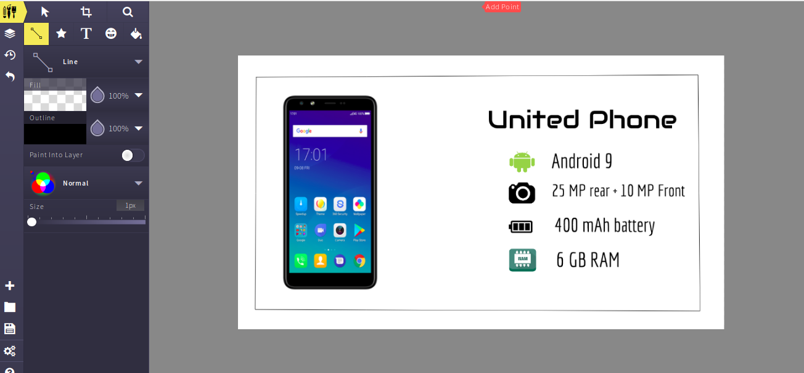

# Step 9:

Change background color

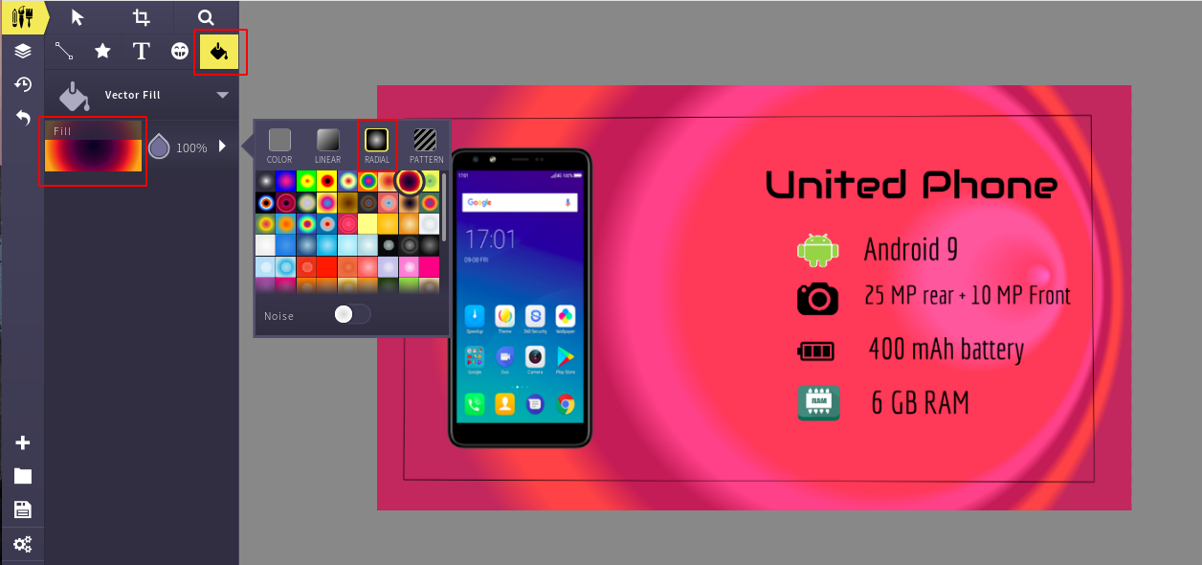

We have used radial color. Select a color from vector fill radial color filled.

# Final Step:

Export the photo as jpeg format

Here we go

# Drawing